**What is IoT (Internet of Things)?**

* Kevin Ashton, in a presentation of Procter & Gamble in 1999, coined the term “Internet of Things“. Almost every area, device, sensor, software, etc are connected to each other.

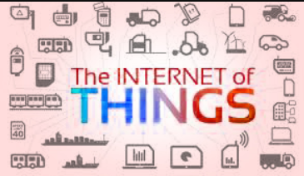

* The Internet of Things (IoT) is growing rapidly because of the increasing use of the internet, technological advancement and the low cost of connection

**20 use cases of IOT**

1. **Smart Home:**

**Remote Control Appliances**

IoT powered home appliances let residents remotely switch on and off devices using smartphone apps to avoid incidents and save energy. Additionally, these devices can make autonomous decisions based on sensor inputs such as preparing fresh coffee when a resident is identified to wake up. Other examples of autonomous or remote controlled actions include:

* turning on lights
* starting the coffee maker,
* setting temperature,
* open up a music playlist,
* 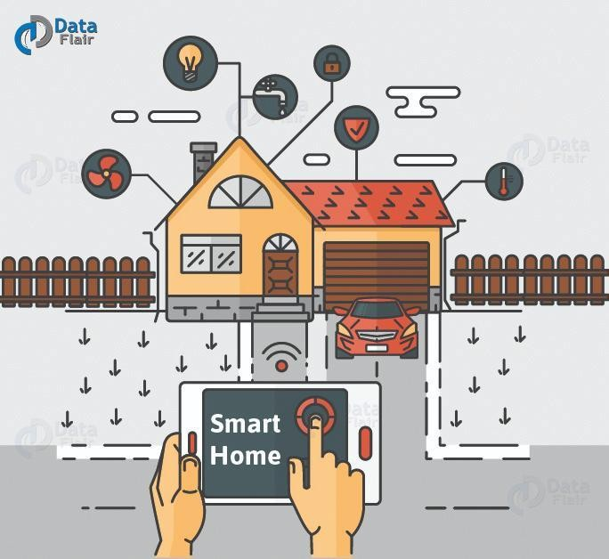Locking doors.

### b. Wearable:

* Just like smart homes, wearables remain a hot topic too among potential IOT applications. Every year, consumers all across the globe await the release of Apple’ smartwatch.
* Apart from this, there are plenty of other wearable devices that make our life easy such as the Sony Smart B Trainer, or LookSee bracelet, the Myo gesture control.

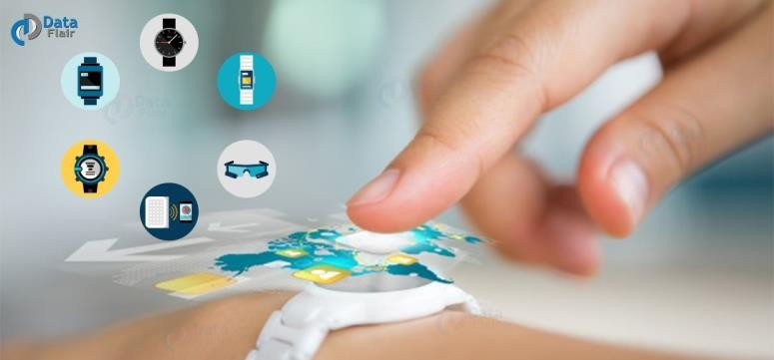

**c.IoT in Agriculture:**

* Different aspects of farming such as the soil condition, heat and humidity can be closely monitored. The irrigation system can be modified to work accordingly with the farming situation.
* The use of drones and livestock monitoring are making sure that we get clean and fresh produce. With smart greenhouse,
* manual labour can be decreased, which in turn reduces production loss, labour cost, and

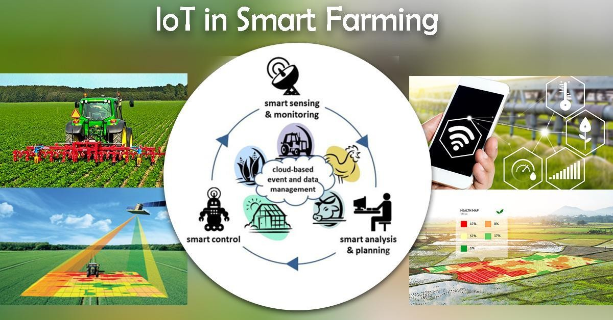

* energy loss. It is an all-around efficient way of solving the world food problem.

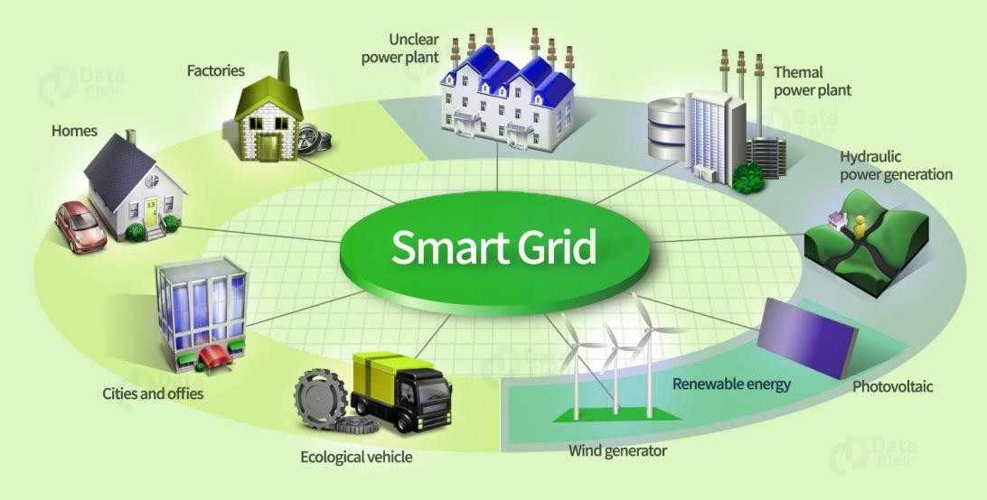

*Uses of IoT – Smart Grid*

### d. Smart Grids:

* Smart grids is another area of application that stands out. A smart grid basically promises to extract information on the behaviors of consumers and electricity suppliers in an automated fashion in order to improve the efficiency, economics, and reliability of electricity distribution.

### e. Industrial Internet

* One way to think of the Industrial Internet is, as connecting machines and devices in industries such as power generation, oil, gas, and healthcare. It is also made use of in situations where unplanned downtime and system failures can result in life-threatening situations.
* A system embedded with the IoT tends to include devices such as fitness bands for heart monitoring or smart home appliances. These systems are functional and can very well provide ease of use but are not reliable because they do not typically create emergency situations if a downtime was to occur.

### f. Connected Car

* Connected car technology is a vast and an extensive network of multiple sensors, antennas, embedded software, and technologies that assist in communication to navigate in our complex world. It has the responsibility of making decisions with consistency, accuracy, and speed.
* It also has to be reliable. These requirements will become even more critical when humans give up entirely the control of the steering wheel and brakes to the autonomous or automated vehicles that are being successfully tested on our highways right now.

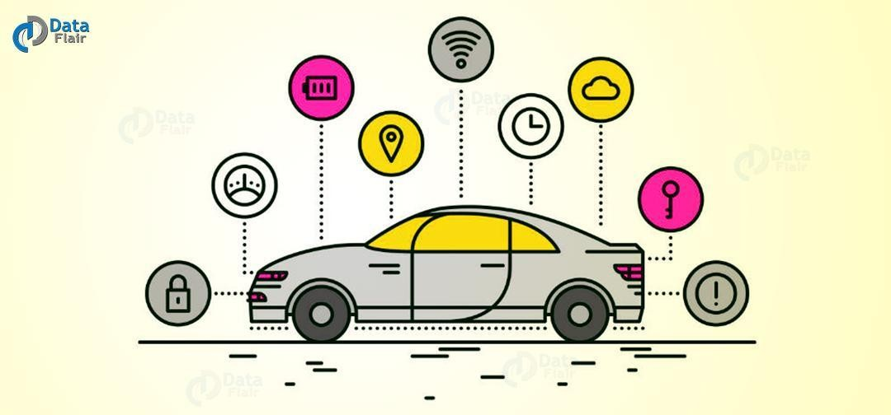

IoT Applications – Connected Car

### g. Connected Health (Digital Health/Telehealth/Telemedicine)

* IoT has various **applications in healthcare**, which are from remote monitoring equipment to advance & smart sensors to equipment integration. It has the potential to improve how physicians deliver care and also keep patients safe and healthy.
* Healthcare IoT can allow patients to spend more time interacting with their doctors by which itHealthcare IoT can allow patients to spend more time
* interacting with their doctors by which it can boost patient engagement and satisfaction. can boost patient engagement and satisfaction.

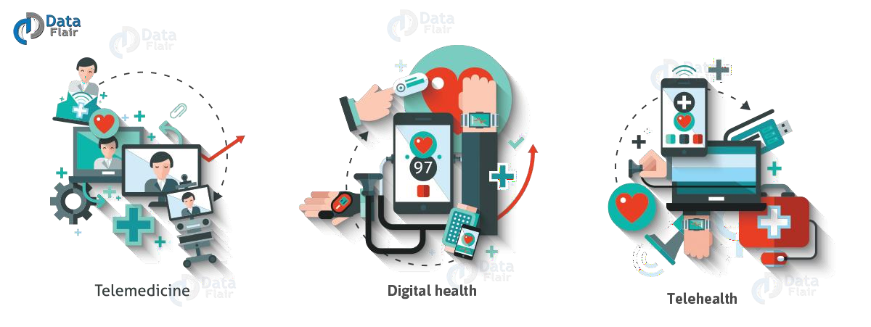

Internet of Things Applications – Connected Health

### h. Smart Retail

* Retailers have started adopting IoT solutions and using IoT embedded systems across a number of applications that improve store operations such as increasing purchases, reducing theft, enabling inventory management, and enhancing the consumer’s shopping experience.
* Through IoT physical retailers can compete against online challengers more strongly. They can regain their lost market share and attract consumers into the store, thus making it easier for them to buy more while saving money.

**i. Smart Supply Chain**

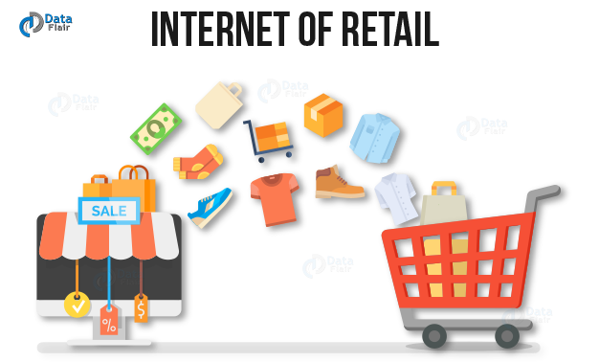

Uses of IoT – Smart Retail

* Supply chains have already been getting smarter for a couple of years. Offering solutions to problems like tracking of goods while they are on the road or in transit, or helping suppliers exchange inventory information are some of the popular offerings.
* With an IoT enabled system, factory equipment that contains embedded sensors communicate data about different parameters such as pressure, temperature, and utilization of the machine. The IoT system can also process workflow and change equipment settings to optimize performance.

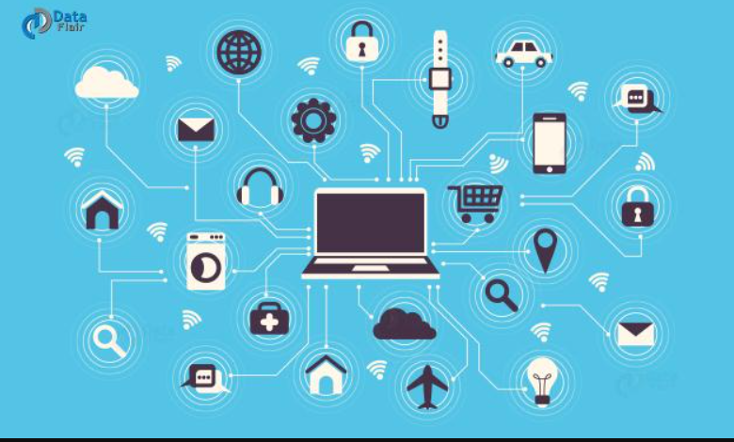

**j.Smart Boards**

* The times have changed. The current day students enjoy smartboards way more than black boards. Smart boards are interactive white boards that projects subject images. It enables the teachers and students to interact with it. How? Bysimply writing on it or moving it around the class. It is much more fun and exciting than it is seems at the moment

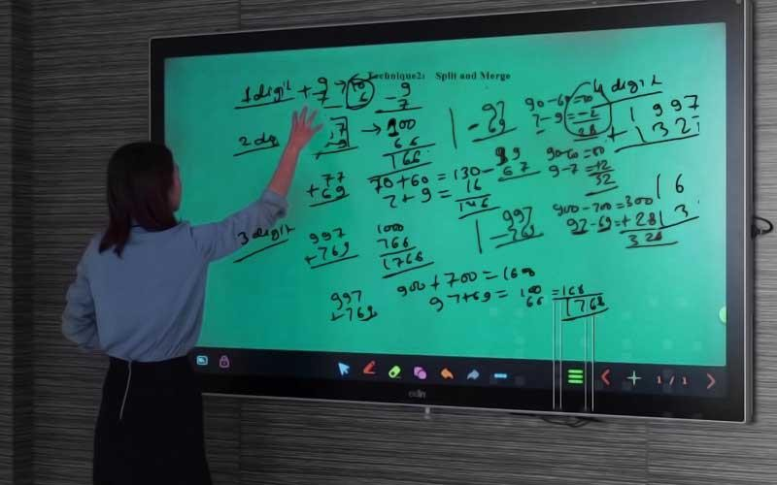

**k.Water Quality management:**

* IoT sensors determine the what kind of chemicals are in the water. They also identify metrics such as total dissolved solids (TDS), bacteria, chlorine, electrical conductivity, etc. This will assist in accessing the real- time, precise quantification of results and will also offer the capability to pinpoint the difficultareas.

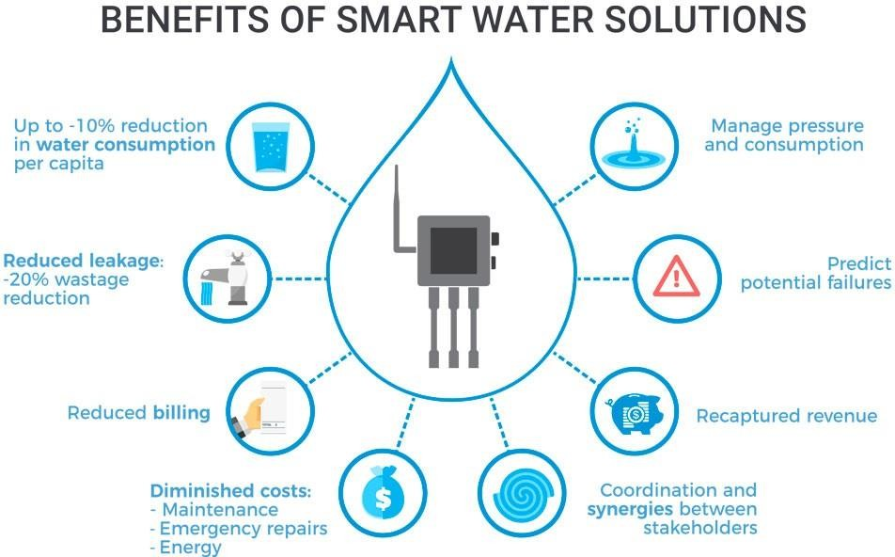

**l.Water Conservation**

* A smart water management system ensures protection from water damage, flooding, and unpleasant surprises in your water bill. The digital system identifies unusual water consumption, both, in open and concealed areas

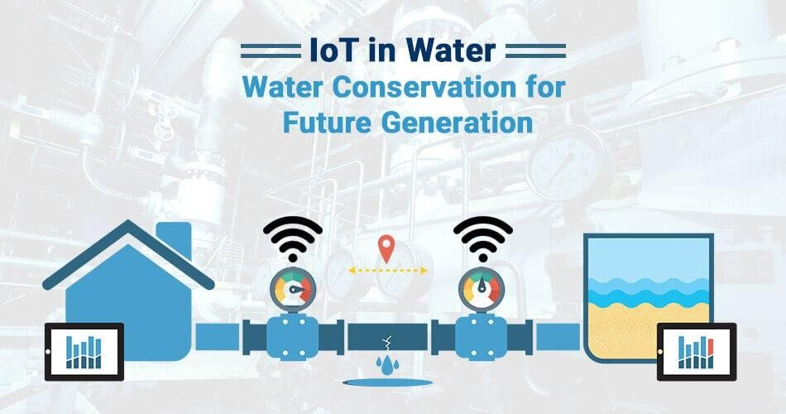

**M.Smart Parking**

* In cities parking is a big problem. With iot sensors, parking problems in a city can be minimized.
* The IoT device consists of an ESP8266 microcontroller and an HC-SR04 distance measurement sensor. The sensor periodically measures the distance and transmits this data tothe microcontroller, which is connected to AWS IoT service viathe MQTT protocol

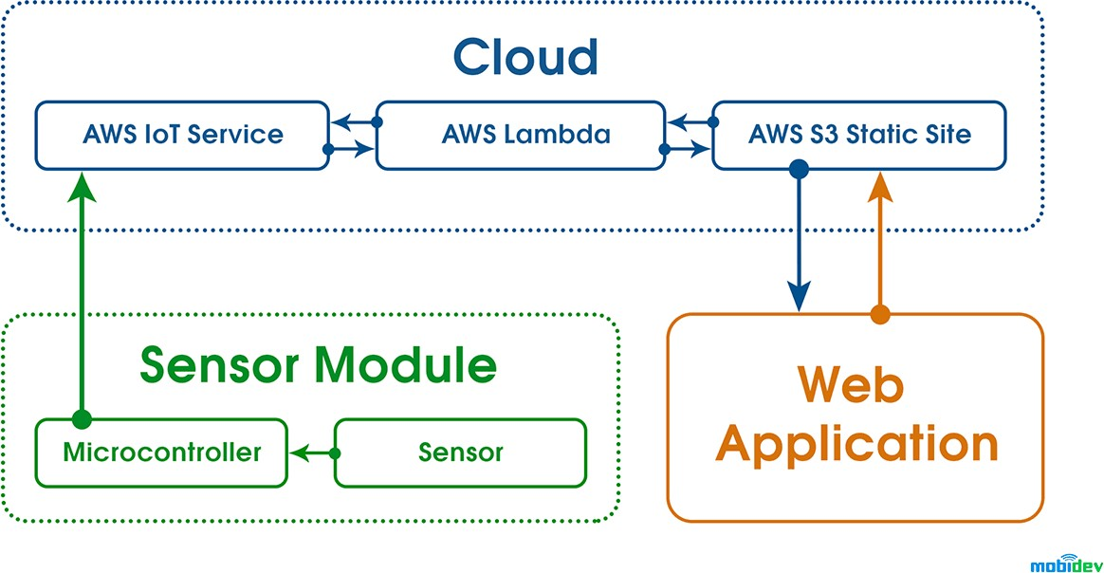

**N.Ultraviolet Radiation Monitoring**

* Visible light: Wavelengths between 0.4 and 0.8 micrometres,
* Ultraviolet light: Wavelengths shorter than 0.4 micrometres,
* Infrared light: Wavelengths longer than 0.8 micrometres.

